Project - End-to-End Kubernetes Implementation
Submission Date: April 3rd 2026

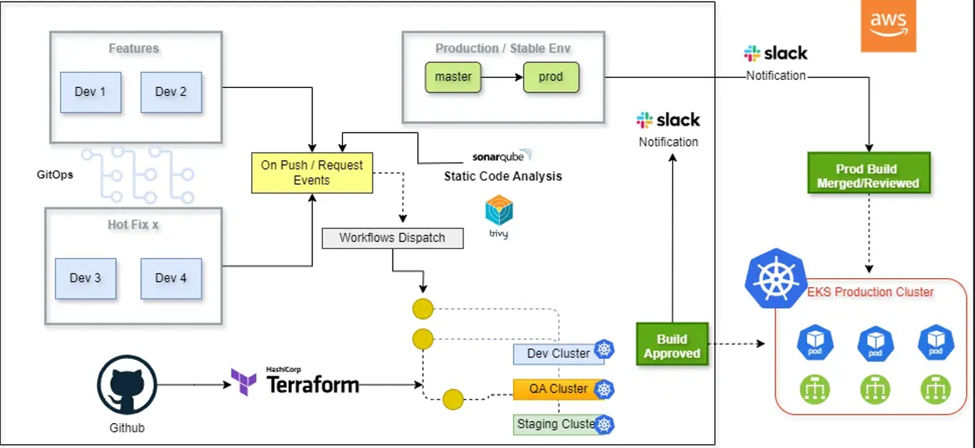
Steps:
- Provision EKS using Terraform
- Setup EKS and GitOps
- Install ArgoCD
- CICD Pipeline using GitHub Actions on Push
- Static Code Analysis using Sonarqube
- Sercurity Scan using Trivy
- Build Docker Image
- Push to Image registry
- Define Deploymebt Evnironments
- Auto Sync via ArgoCD
Flow
Workflow:
- Dev pushes code → triggers pipeline
- Image built + scanned
- Deploy to Dev cluster
- Manual approval
- Promote to QA → Staging → Prod
6.Integrate Slack Notifications
7.Deploy to EKS Production Cluster
8 .Branch Strategy
17. Git Flow
- dev → development
- qa → testing
- staging → pre-prod
- master → production

Complete Flow Summary
- Developer pushes code → GitHub
- GitHub Actions triggers pipeline
- Code scanned (SonarQube + Trivy)
- Docker image built & pushed
- ArgoCD detects manifest changes
- Deploys to Dev → QA → Staging
- Manual approval → Production
- Deploys to EKS
- Slack notifications sent

What You Achieve
- GitOps-based deployment
- Secure CI/CD (DevSecOps)
- Multi-environment promotion
- Automated Kubernetes deployment
- Production-ready architecture

